System Description

General
There are 2 identical Paint detection systems, one for the Basecoat (red) and one for the Topcoat (green). What follows applies to both systems.
The Paint inspection system is based on 2 x Digital Linescan Cameras feeding into a frame grabber with 2 camera link connections.
A software application (Paint App) gathers the data from the line scan cameras as 2 asynchronous streams of data, processes the data then reports the presence of blips and streams to the PLC and the FIX system.

Lens: Camera: FO Driver
PC with Franegrabber
Lens: Camera: FO Driver
Fibre Optic
Plant PLC
4x Output Lines
FIX Server
Ethernet

Fibre Optic Line Drivers
In order to drive the camera signals over the required 25m the camera link interface on the back of the camera is linked to a fibre optic extender which consists of 2 driver units, one attached to the camera, the other attached to the frame grabber.
The camera and grabber FO drivers are different.
The fibre optic connection uses a twin fibre per connection in a cross over configuration.
Note: The fibre optic unit must be powered up after the camera, otherwise the link will fail. For connection debugging details see Phire Fibre Optic Debugging

Plant Connections
The plant PLC connection is via an internal National Instruments Output card that has built in Opto Isolation.
The Paint Application provides an OPC server that links it to the fix system over the factory ethernet. The SLIKDA OPC server control is provided by Northern Dynamic. c.f. www.nordyn.com/Downloads/Files/Documents/SLIKDADataSheet-print.pdf

Data Processing
The frame grabber accumulates the image data into frames that are 2048 wide and 512 high. When a new frame is ready it signals the application and the image frame is processed whilst the next frame is being accumulated (double buffering).

A threshold is applied to the image and all points in the image above the threshold are processed (dark field imaging). These pixels are linked together to form discrete features (blob detection) and the bounding box of each blob is stored.

If the blob touches the top and bottom of the image it is characterised as a Stream, otherwise it is labelled as a Blip.

After the current frame has been processed if there are any blips or streams the appropriate digital output is held high for 0.5s.

The statistics for blips and streams are recalculated every minute and the FIX client will access these periodically.

Paint Application User Interface

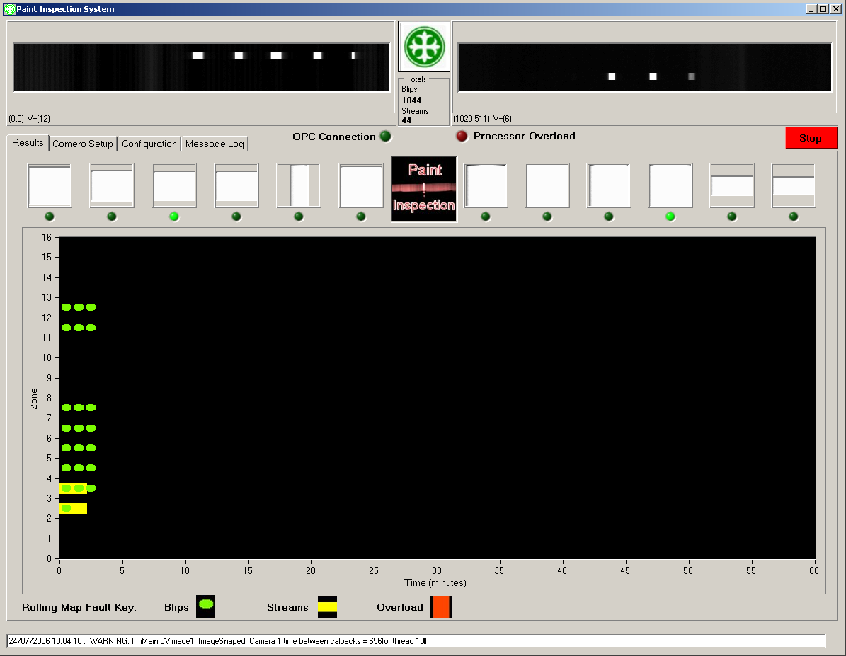

UI Description
The User interface shows the live images from the cameras and under these a series of small images (tiles) which represent a circular buffer of the last 6 faults seen from each camera. The green lamp indicates the most recent fault going from right to left and wrapping at the end.
Underneath this there are a series of tabbed screens, namely
Results: (shown) that displays a rolling map of faults based on their type (blip/stream) and position (zone) for the last hour.

Camera Setup: (see below) Is protected by password control and gives an oscilloscope type view of the linescan cameras. From here the detection threshold can be altered along with the dead bands at the beginning and end of each camera and the gain for each camera. The overload factor is the number of pixels above the threshold that will stop processing from being attempted and is normally set to around 10% (0.1).

Configuration: Is protected by password and holds setup parameters for the program and should not normally be altered! The ability to save images as a debuging tool is also located here. (this should not be left on permanently as it will fill up the hard disk!

Message Log: Is where program messages are displayed in order to understand the status of the system. The latest Error or Warning Message is also displayed at the bottom of the UI.

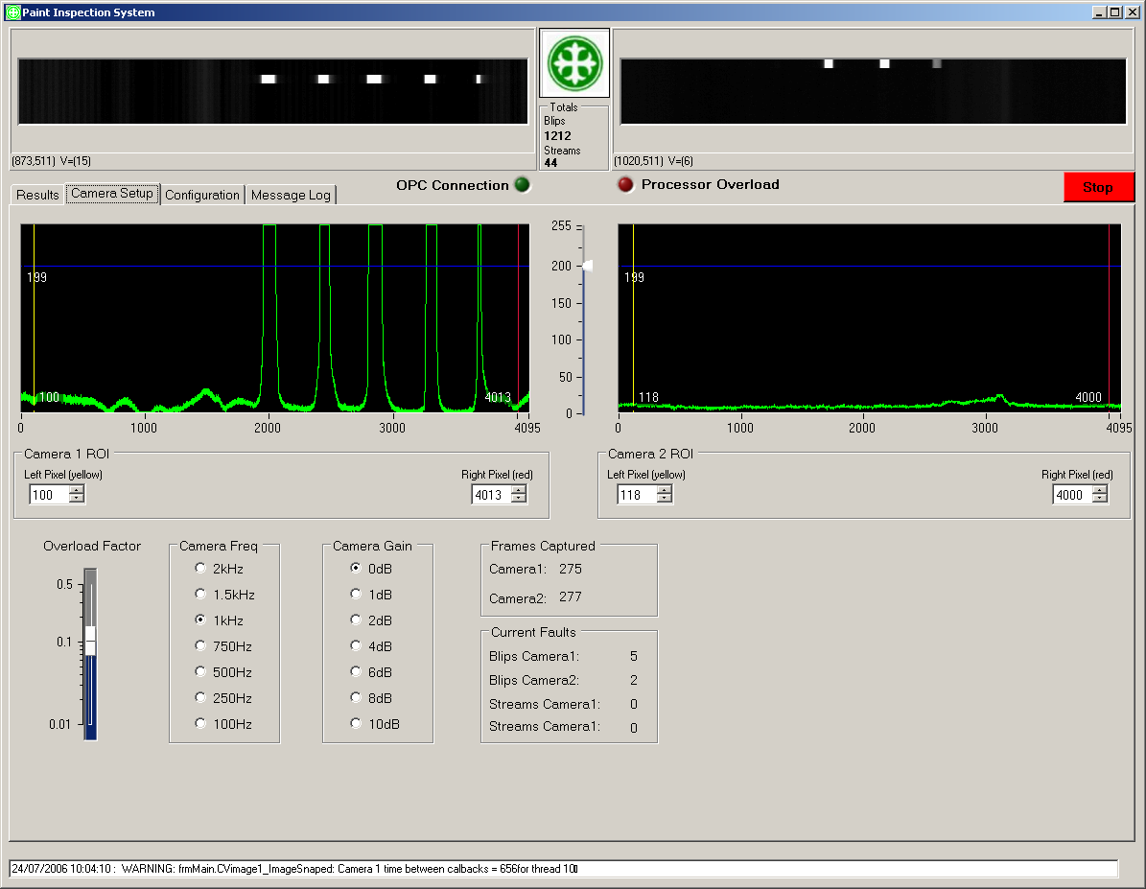

Paint System Fault Reporting to the PLC and FIX System
Blips & Stream Statistics Generation
You cannot accumulate statistics from the blobs on the fly and just store the overall counts if you want to be able to say, give me stats for the last hour (8hours, 24hours) from now, as now is constantly changing. This means you have to store 24 hours worth of blob data and regenerate the stats from the data every time you post the results.

In order to reduce both processing and development time, I have produced 2 views of the faults.
- Record faults according to there size distribution in one of four categories: small, medium, large, and very large.
- Record faults in terms of there position across the curtain where the curtain is divided into 16 regions (~200mm per region).This assumes the operator needs to know roughly which area they are in so he can clear the fault.

The faults are aggregated together in time into separate counters based on size category (1) and zone position (2), with a interval in minutes that is configurable with a minimum value of 1 minute.

The blip statistics will be recorded as a count for each zone and for each size category, whereas stream statistics will be accumulated on the basis of their duration in seconds for each zone.

Blips & Stream Digital outputs
The digital outputs are straight forward i.e. if there is a blob in the current image, turn the output on for 0.5s. If the output is already on then you already registered the presence of a blob so don’t do anything.
If it is a stream (i.e. it touches the both the top and bottom of the image) then turn the stream output on whilst a stream is present. No distinction is possible between thinning and streams.

Rolling Map
I have utilised a XY plot to create a rolling map of Faults based on there distribution across the zones. The map displays the last hour and scrolls in intervals of one minute.

OPC Stats
The following stats are available via OPC

OPC Tag Name Description

Blips.All CountLastHour INT count of all blips for last hour
Blips.Small CountLastHour INT count of small blips for last hour
Blips.Medium CountLastHour INT count of medium blips for last hour
Blips.Large CountLastHour INT count of large blips for last hour
Blips.XLarge CountLastHour INT count of Xlarge blips for last hour
Blips.All CountLast8Hour INT count of all blips for last 8hours
Blips.All CountLast24Hour INT count of all blips for last 24hours

Streams.All SecondsLastHour INT seconds of all streams for last 8hours
Streams.Small SecondsLastHour INT seconds of small streams for last hour
Streams.Medium SecondsLastHour INT seconds of medium streams for last hour
Streams.Large SecondsLastHour INT seconds of large streams for last hour
Streams.XLarge SecondsLastHour INT seconds of Xlarge streams for last hour
Streams.All SecondsLast8Hour INT seconds of all streams for last 8hours
Streams.All SecondsLast24Hour INT seconds of all streams for last 24hours

Setting up the System

Camera Focus
Since the cameras cannot be accessed safely when installed the focus must be set and locked before installation.
This is done by mounting the cameras at a fixed distance from a target with vertical lines on e.g. a 2m steel tape measure with a light shining on it.
The distance must be the same as the installed distance from the front of the lens to the paint curtain, i.e. 1810mm.
The focus is set to give the sharpest image over the entire range.
Once achieved the focus locking mechanism is screwed in to stop it moving.
The lens aperture should be fully open.

Mechanical Camera Alignment
Once mounted in the correct place and after the white board has been installed and it’s height correctly adjusted the following procedure should be used to align the cameras. The 3 point adjustment will allow correction for horizontal and vertical tilt. Use the Sapera Cam Expert program (shortcut located on the desktop) to view the camera image.
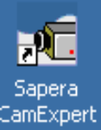

- Remove the Paint curtain so that the entire white board is visible.

- Wind the 2 front adjusters so that the height from the conveyor is 16mm. This will give 10mm clearance from the thickest glass (6mm)

- Wind the back adjuster up or down till the bottom edge of the board can be seen on the monitor. Stop when it is right on the edge, you will probably see one side go dark while the other is white. This is due to cross-line tilt.

- Use the 2 front adjusters to correct this tilt. If the image is all white use the back adjuster to move it closer to the edge.

- Repeat these steps until the best balance is achieved.

- Turn the back adjuster anticlockwise to move the camera across the entire white board and count the number of half turns (9). This corresponds to a vertical movement of 60mm and means that 0.5 turn = 6.6mm.

- Go back in the opposite direction and find the bottom edge again.

- Rotate the back adjuster anticlockwise one turn to place the field of view 6mm from the edge.

Determining the Overlap etc

- Place the 4m rod in the place where the paint curtain is and position it such that the cameras can see under it.

- Use the slide and black pointer to interrupt the image and put a black line on it.

- Use this to determine the position of the start and end for each camera relative to some datum e.g. the edge of the conveyor.

- These measurements give you the field of view for each camera and by subtracting the start position of camera 2 from the end position of camera 1 you determine the overlap.

- Enter the values into the configuration page of the application into the following fields:

Align_Cam1Startmm
Align_Cam1Endmm
Align_Cam2Startmm
Align_Cam2Endmm

System Operation

The System works in Dark Field mode i.e. it inspects bright objects on a dark background.
3 x 1.5m fluorescent tubes span the line and the centre tube overlaps the end tubes.

The lights shine down on a diffuser mounted at 45degrees and the cameras are pointed at the diffuser. The diffuser is used to form the light source because it can be mounted much closer to the glass (~10mm away). It also provides a uniformly scattering surface.

When the paint curtain is present no signal is received by the system because the threshold is set high enough such that the background level doesn’t trigger the threshold. When the paint curtain is interrupted the camera can see through to the diffuser and a signal is detected.

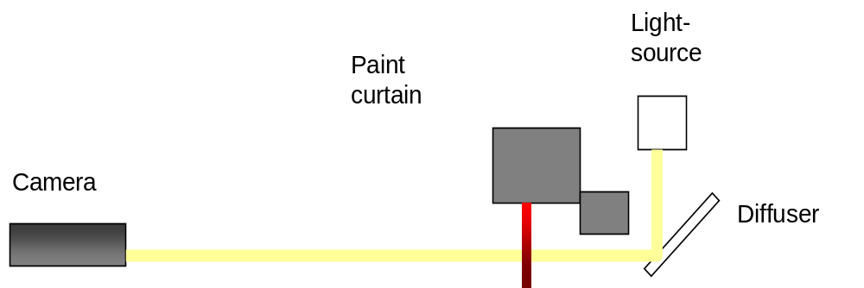

Computer System Description and External Connections
The Bottom and Top coat are treated as 2 separate systems each with their own PC.
A 19 inch rack mount industrial PC is used with the XP professional operating system.

The PC has 2 hard disks configured as Raid 1 i.e. mirroring. This means both disks have exactly the same information on and if one fails the other takes over (100% redundancy). When the faulty disk is replaced, it will be rebuilt from the other.

The two cameras (left and right) are connected via the fibre optic link to a frame grabber card (Coreco X64CLiPro) mounted in the PC.
The external connections (outputs) to the PLC are made through a National Instruments Digital IO card with integral Opto-Isolation (Ni6518).

The computer systems are configured to autostart and autologin with the domain account “zzch2instrumentation”, password “development”. This account has local administrator rights on the machine.

Typical Images: Blip, Thinning, Stream



Debugging the Phire Fibre Optic Driver Connections
There is one unit that connects to the camera and another that connects to the PC. These look identical other than a black dot next to the appropriate label, make sure you have one of each and they are connected the right way round.

The fibre optic cable is a twin cable and the fibres must be crossed over.

The Camera must be powered up for ~10s before the fibre optic driver connected to it otherwise the link cannot be established.

When the link is healthy the green Led will be continuously on and the red Led will be off.

FO extender link Diagnostic Table
Camera FO Extender |  | PC FO Extender |  | Meaning
Red LED | Green LED | Red LED | Green LED
Off | Off | Off | Off | No power - check plug orientation
flashing | flashing | flashing | flashing | PC FO extender connected to Cam etc- swap
flashing | On | flashing | flashing | Fibres not crossed - swap
Off | flashing | unknown | unknown | No pixel clock from camera – power off the camera FO extender and camera and power up camera first then the extender after 10s
Off | On | Off | On | Link OK

Using Sapera Cam Expert to view the cameras

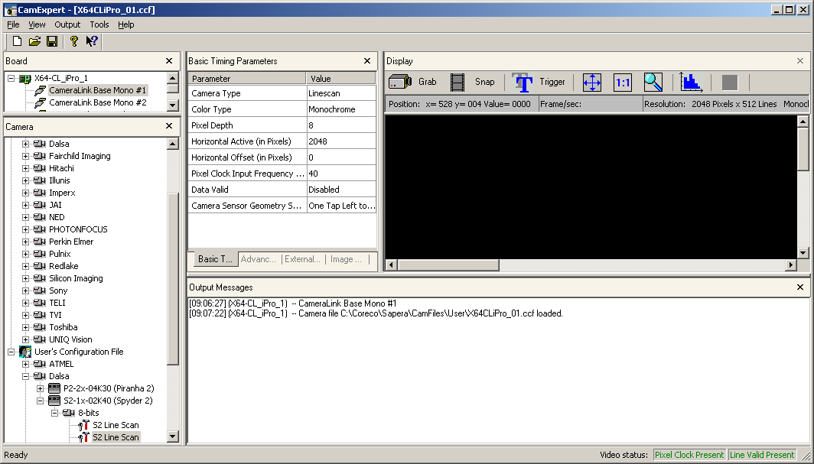

- Select the appropriate camera (Cameralink Base Mono 1 or 2) see top left.

- Select the appropriate camera configuration file (S2 line scan) see bottom left.

- Press snap to check the acquisition is working. If you get a “pixel clock” error message it probably indicates a problem with the fibre optic link.

- Press 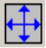 to see all of the image at once, or use the scroll bars to view in more detail.

Communicating with the cameras using hyperterminal

- You can check the cameras is responding using the two links to hyperterminal on the desktop:

- 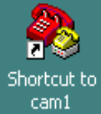 for camera 1 on COM4 and  for camera 2 on COM5

- these can only be used if the application is not running.

- the settings used are 9600,no parity, 8,1,no flow control.

- Once connected if you type in gcp<CR> you can view the cameras set up.

- If you get an error message saying can’t open the comm port using this or the application then try rebooting the PC and this should clear the comm. port.

The gcp command should yield results similar to below (the analog gain will be +6 or 8).

G E N E R A L C A M E R A S E T T I N G S:
Camera Model No.: S2-12-02K40
Camera Serial No.:
Sensor Serial No.: 000000000
Camera Network ID: 0
Network Message Mode: disabled
Firmware Design Rev.: 03-39-00428-03 Feb 21 2
DSP Design Rev.: 0.3
SETTINGS FOR UNCALIBRATED MODE:
Analog Gain (dB): +0.0
Analog Offset: 664
SETTINGS FOR CALIBRATED MODE:
Analog Gain (dB): +0.0
Analog Offset: 0
Digital Offset: 0
Calibration Status: FPN [uncalibrated] PRNU [u
SETTINGS COMMON TO CALIBRATED AND UNCALIBRATED MODES:
System Gain: 0 0
Background Subtract: 0
Pretrigger:
Number Of Line Samples: 64
Video Mode: uncalibrated
Data Mode: 0
Exposure Mode: 2
SYNC Frequency: 1000 (999.973) Hz
Exposure Time: 999.700 uSec
End-Of-Line Sequence: on
Upper Threshold: 240
Lower Threshold: 15
Region Of Interest: 0001 - 2048

Additional Documents and Links

National Instruments DIO Card
Double click here to view the manual


PLC Connections wired to the green terminal blocks on the computer shelves as follows:
Name Connection Use
+24v 10,28&29 supply for opto-isolators
0v 19, earth supply for opto-isolators
o/p 1 11 (P2.0) Blip output
o/p 2 30 (P2.1) Stream output
o/p 3 12 (P2.2) System Status
o/p 4 31 (P2.3) reserved for expansion
Pos bit0 13 (P2.4) position address bit
Pos bit1 32 (P2.4) position address bit
Pos bit2 14(P2.4) position address bit
Pos bit3 33 (P2.4) position address bit
Pos bit4 15 (P2.4) position address bit
Pos bit5 34 (P2.4) position address bit
Pos bit6 16 (P2.4) position address bit
Pos bit7 35 (P2.4) position address bit
Pos bit8 17 (P2.4) position address bit
Pos bit9 36 (P2.4) position address bit
Pos bit10 18 (P2.4) position address bit
Pos bit10 37 (P2.4) position address bit

Dalsa Spyder2 2048 Linescan Camera
Double click here to view the manual
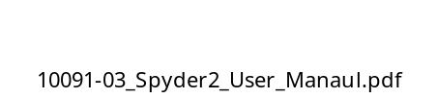

Northern Dynamic SLIKDA OPC Server Control
Double click here to view the manual


Software Driver Installation
NIDAQ drivers from the Measurement studio 8 disks:

NI Labview RunTime Engine 7.1.1
NI Measurement & Automation Explorer 4.0.3
NI-DAQmx

CVB 9.0 software and drivers
Coreco Sapera LT 5.20
Coreco X64-CLiPro Device Driver 1.10.01.0239

Common Vision Blox Config Files Sapera
Common Vision Blox Imaging Sapera Based Drivers
Common Vision Blox Image Manager
Common Vision Blox Blob

Install order:
1> Sapera lite
2> Board Level Libraries
3> CVB

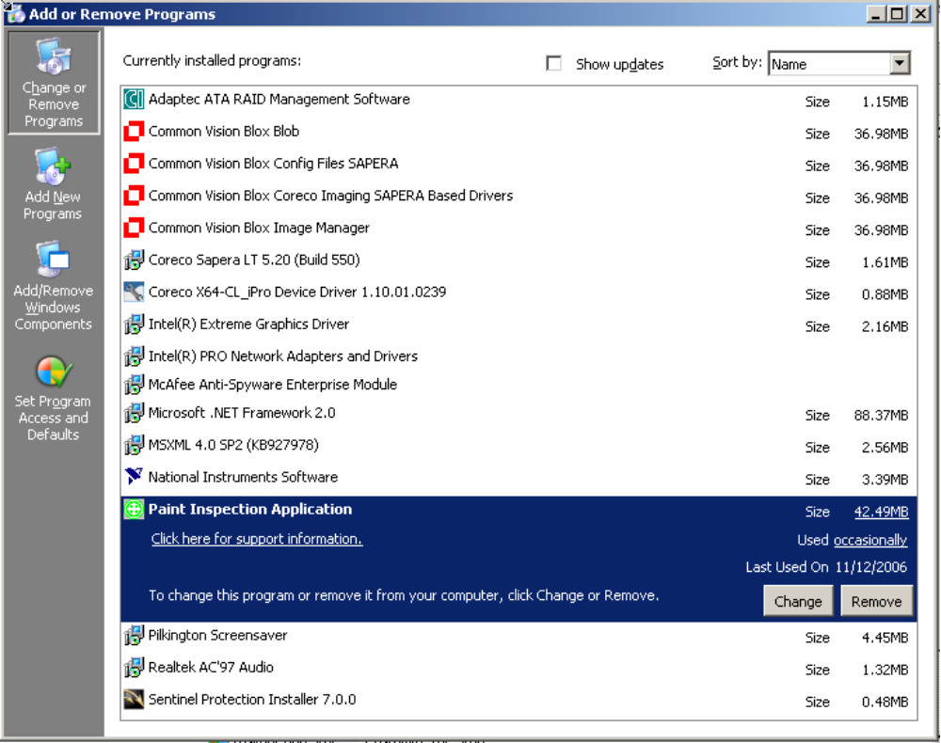

OS Recovery
- put windows XP with sp2 install disc into drive and reboot from CD
- press any key to boot from CD
- as soon as blue setup screen appears press F6
- press S for select disk driver and put driver into floppy drive and press <CR>
- press enter to Setup not enter the recovery console
- widows searches for installed version - select 1 for the previously installed version
- press R to repair it

- alternatively enter the recovery console if you know which file you need to replace
- you will need the admin password which is “administrator”

